IP address

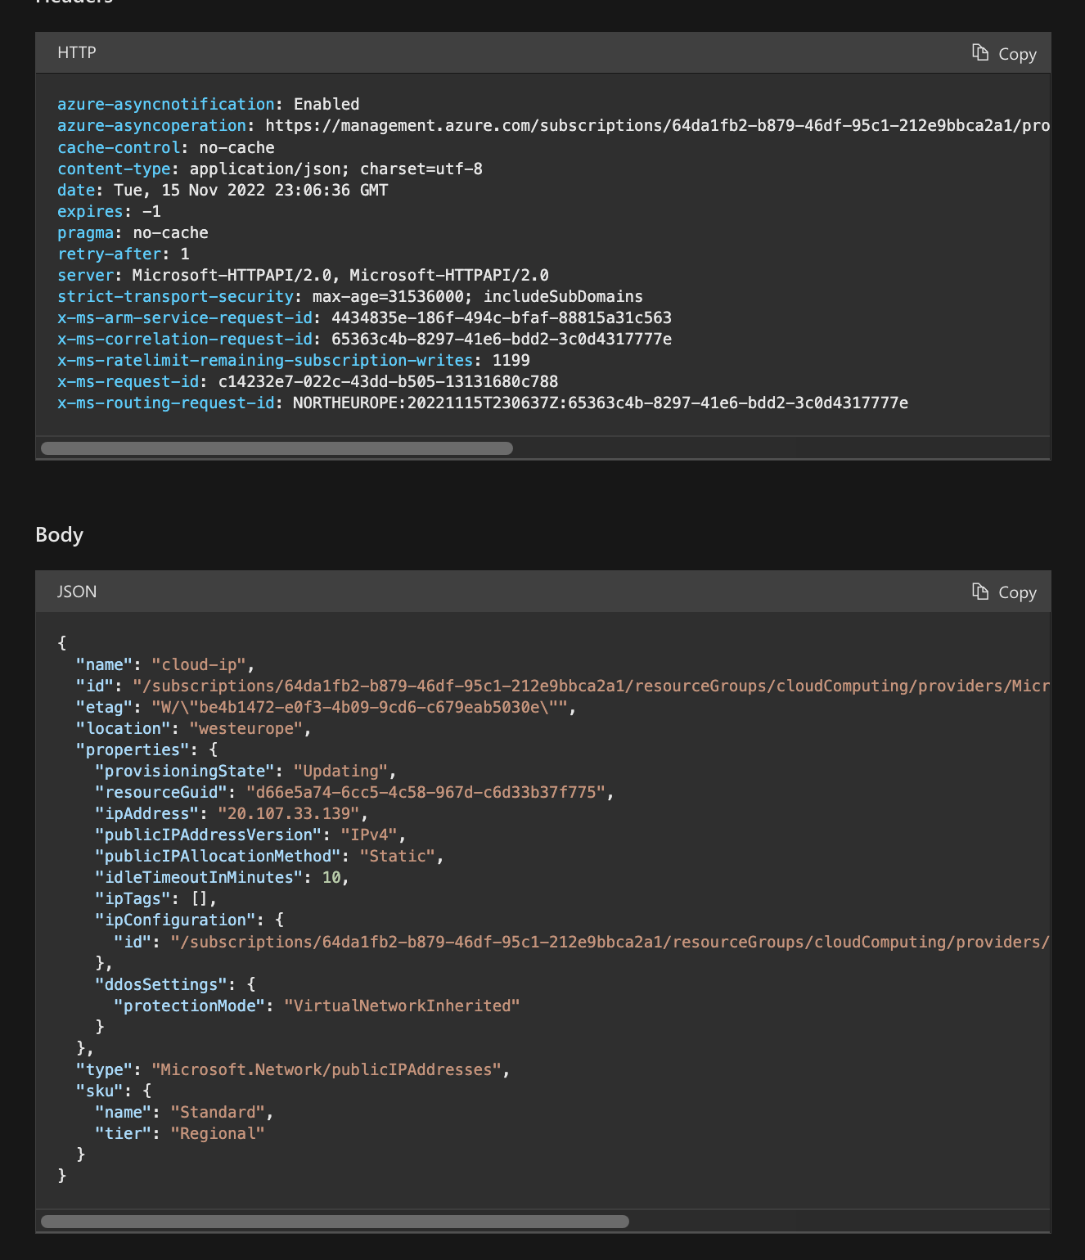

Json

{

"name": "cloud-ip",

"id": "/subscriptions/64da1fb2-b879-46df-95c1-212e9bbca2a1/resourceGroups/cloudComputing/providers/Microsoft.Network/publicIPAddresses/cloud-ip",

"etag": "W/\"be4b1472-e0f3-4b09-9cd6-c679eab5030e\"",

"location": "westeurope",

"properties": {

"provisioningState": "Updating",

"resourceGuid": "d66e5a74-6cc5-4c58-967d-c6d33b37f775",

"ipAddress": "20.107.33.139",

"publicIPAddressVersion": "IPv4",

"publicIPAllocationMethod": "Static",

"idleTimeoutInMinutes": 10,

"ipTags": [],

"ipConfiguration": {

"id": "/subscriptions/64da1fb2-b879-46df-95c1-212e9bbca2a1/resourceGroups/cloudComputing/providers/Microsoft.Network/networkInterfaces/cloud610/ipConfigurations/ipconfig1"

},

"ddosSettings": {

"protectionMode": "VirtualNetworkInherited"

}

},

"type": "Microsoft.Network/publicIPAddresses",

"sku": {

"name": "Standard",

"tier": "Regional"

}

}

azure-asyncnotification: Enabled

azure-asyncoperation: https://management.azure.com/subscriptions/64da1fb2-b879-46df-95c1-212e9bbca2a1/providers/Microsoft.Network/locations/westeurope/operations/c14232e7-022c-43dd-b505-13131680c788?api-version=2022-05-01

cache-control: no-cache

content-type: application/json; charset=utf-8

date: Tue, 15 Nov 2022 23:06:36 GMT

expires: -1

pragma: no-cache

retry-after: 1

server: Microsoft-HTTPAPI/2.0, Microsoft-HTTPAPI/2.0

strict-transport-security: max-age=31536000; includeSubDomains

x-ms-arm-service-request-id: 4434835e-186f-494c-bfaf-88815a31c563

x-ms-correlation-request-id: 65363c4b-8297-41e6-bdd2-3c0d4317777e

x-ms-ratelimit-remaining-subscription-writes: 1199

x-ms-request-id: c14232e7-022c-43dd-b505-13131680c788

x-ms-routing-request-id: NORTHEUROPE:20221115T230637Z:65363c4b-8297-41e6-bdd2-3c0d4317777e

Network Interface

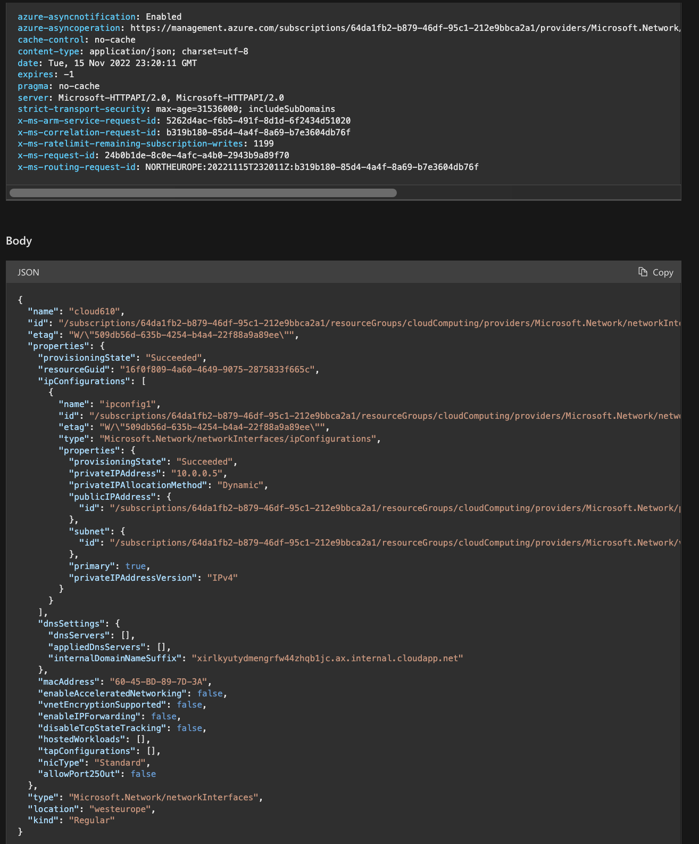

HTTP:

azure-asyncnotification: Enabled

azure-asyncoperation: https://management.azure.com/subscriptions/64da1fb2-b879-46df-95c1-212e9bbca2a1/providers/Microsoft.Network/locations/westeurope/operations/24b0b1de-8c0e-4afc-a4b0-2943b9a89f70?api-version=2022-05-01

cache-control: no-cache

content-type: application/json; charset=utf-8

date: Tue, 15 Nov 2022 23:20:11 GMT

expires: -1

pragma: no-cache

server: Microsoft-HTTPAPI/2.0, Microsoft-HTTPAPI/2.0

strict-transport-security: max-age=31536000; includeSubDomains

x-ms-arm-service-request-id: 5262d4ac-f6b5-491f-8d1d-6f2434d51020

x-ms-correlation-request-id: b319b180-85d4-4a4f-8a69-b7e3604db76f

x-ms-ratelimit-remaining-subscription-writes: 1199

x-ms-request-id: 24b0b1de-8c0e-4afc-a4b0-2943b9a89f70

x-ms-routing-request-id: NORTHEUROPE:20221115T232011Z:b319b180-85d4-4a4f-8a69-b7e3604db76f

JSON:

{

"name": "cloud610",

"id": "/subscriptions/64da1fb2-b879-46df-95c1-212e9bbca2a1/resourceGroups/cloudComputing/providers/Microsoft.Network/networkInterfaces/cloud610",

"etag": "W/\"509db56d-635b-4254-b4a4-22f88a9a89ee\"",

"properties": {

"provisioningState": "Succeeded",

"resourceGuid": "16f0f809-4a60-4649-9075-2875833f665c",

"ipConfigurations": [

{

"name": "ipconfig1",

"id": "/subscriptions/64da1fb2-b879-46df-95c1-212e9bbca2a1/resourceGroups/cloudComputing/providers/Microsoft.Network/networkInterfaces/cloud610/ipConfigurations/ipconfig1",

"etag": "W/\"509db56d-635b-4254-b4a4-22f88a9a89ee\"",

"type": "Microsoft.Network/networkInterfaces/ipConfigurations",

"properties": {

"provisioningState": "Succeeded",

"privateIPAddress": "10.0.0.5",

"privateIPAllocationMethod": "Dynamic",

"publicIPAddress": {

"id": "/subscriptions/64da1fb2-b879-46df-95c1-212e9bbca2a1/resourceGroups/cloudComputing/providers/Microsoft.Network/publicIPAddresses/cloud-ip"

},

"subnet": {

"id": "/subscriptions/64da1fb2-b879-46df-95c1-212e9bbca2a1/resourceGroups/cloudComputing/providers/Microsoft.Network/virtualNetworks/cloudComputing-vnet/subnets/default"

},

"primary": true,

"privateIPAddressVersion": "IPv4"

}

}

],

"dnsSettings": {

"dnsServers": [],

"appliedDnsServers": [],

"internalDomainNameSuffix": "xirlkyutydmengrfw44zhqb1jc.ax.internal.cloudapp.net"

},

"macAddress": "60-45-BD-89-7D-3A",

"enableAcceleratedNetworking": false,

"vnetEncryptionSupported": false,

"enableIPForwarding": false,

"disableTcpStateTracking": false,

"hostedWorkloads": [],

"tapConfigurations": [],

"nicType": "Standard",

"allowPort25Out": false

},

"type": "Microsoft.Network/networkInterfaces",

"location": "westeurope",

"kind": "Regular"

}

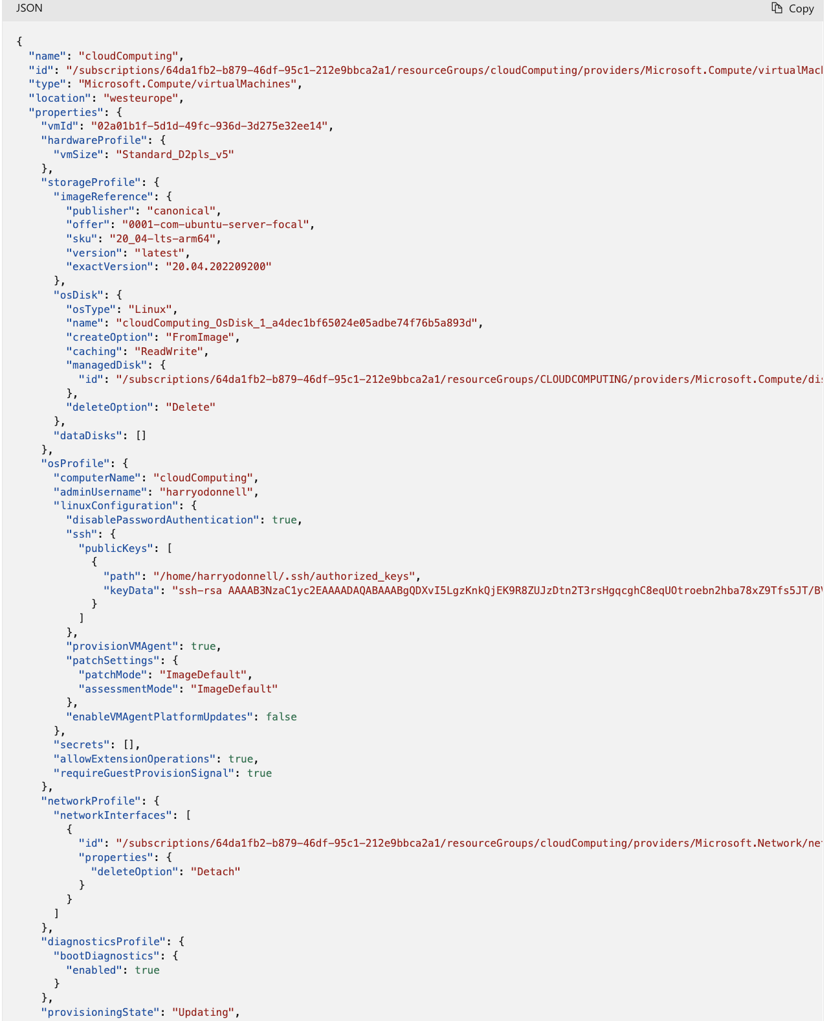

{

"name": "cloudComputing",

"id": "/subscriptions/64da1fb2-b879-46df-95c1-212e9bbca2a1/resourceGroups/cloudComputing/providers/Microsoft.Compute/virtualMachines/cloudComputing",

"type": "Microsoft.Compute/virtualMachines",

"location": "westeurope",

"properties": {

"vmId": "02a01b1f-5d1d-49fc-936d-3d275e32ee14",

"hardwareProfile": {

"vmSize": "Standard_D2pls_v5"

},

"storageProfile": {

"imageReference": {

"publisher": "canonical",

"offer": "0001-com-ubuntu-server-focal",

"sku": "20_04-lts-arm64",

"version": "latest",

"exactVersion": "20.04.202209200"

},

"osDisk": {

"osType": "Linux",

"name": "cloudComputing_OsDisk_1_a4dec1bf65024e05adbe74f76b5a893d",

"createOption": "FromImage",

"caching": "ReadWrite",

"managedDisk": {

"id": "/subscriptions/64da1fb2-b879-46df-95c1-212e9bbca2a1/resourceGroups/CLOUDCOMPUTING/providers/Microsoft.Compute/disks/cloudComputing_OsDisk_1_a4dec1bf65024e05adbe74f76b5a893d"

},

"deleteOption": "Delete"

},

"dataDisks": []

},

"osProfile": {

"computerName": "cloudComputing",

"adminUsername": "harryodonnell",

"linuxConfiguration": {

"disablePasswordAuthentication": true,

"ssh": {

"publicKeys": [

{

"path": "/home/harryodonnell/.ssh/authorized_keys",

"keyData": "ssh-rsa "

}

]

},

"provisionVMAgent": true,

"patchSettings": {

"patchMode": "ImageDefault",

"assessmentMode": "ImageDefault"

},

"enableVMAgentPlatformUpdates": false

},

"secrets": [],

"allowExtensionOperations": true,

"requireGuestProvisionSignal": true

},

"networkProfile": {

"networkInterfaces": [

{

"id": "/subscriptions/64da1fb2-b879-46df-95c1-212e9bbca2a1/resourceGroups/cloudComputing/providers/Microsoft.Network/networkInterfaces/cloudcomputing97",

"properties": {

"deleteOption": "Detach"

}

}

]

},

"diagnosticsProfile": {

"bootDiagnostics": {

"enabled": true

}

},

"provisioningState": "Updating",

"priority": "Spot",

"evictionPolicy": "Deallocate",

"billingProfile": {

"maxPrice": -1

},

"timeCreated": "2022-09-22T20:50:18.5696432+00:00"

},

"resources": [

{

"name": "AzureNetworkWatcherExtension",

"id": "/subscriptions/64da1fb2-b879-46df-95c1-212e9bbca2a1/resourceGroups/cloudComputing/providers/Microsoft.Compute/virtualMachines/cloudComputing/extensions/AzureNetworkWatcherExtension",

"type": "Microsoft.Compute/virtualMachines/extensions",

"location": "westeurope",

"properties": {

"autoUpgradeMinorVersion": true,

"provisioningState": "Succeeded",

"publisher": "Microsoft.Azure.NetworkWatcher",

"type": "NetworkWatcherAgentLinux",

"typeHandlerVersion": "1.4",

"settings": {}

}

}

]

}

Script

